

Root Finding Methods of Solving Implied Volatility for Black-Scholes Formula
Dr. Xiaoxu Han

Yanzhe Li
Shiyun Liu

- Introduction

In this paper, we research on a number of root finding methods on solving the implied volatility from Black Scholes formula. We consider Bisection method, Muller-Bisection method, Newton method, Halley method, Brent (1973) method, Brenth method, Ridders (1979) method and Newton-Raphson method, and compare the accuracy and efficiency performance on European options. In terms of both accuracy and efficiency, Halley method is found to be the best method among all.

  - Option Pricing Formula - Black Scholes Formula

Black Scholes formula is the most widely used option pricing formula. It relates the price of an option to the current underlying asset price (stock price), the volatility of the underlying asset (Implied Volatility), and other parameters such as options strike price, time to maturity, and risk free rate.

In fact, in the Black Scholes formula, stock price and other parameters including the option strike price, time to maturity, and risk free rate are relatively easy to get, which leaves the implied volatility as a single factor that decides the option price. If given that all values are known, the theoretical option price can be calculated as follows.

The value of a call option:
$$C=S_{t}N\left(d_{1}\right)- N\left(d_{2}\right) K e^{-r(T- t)}$$
The value of a put option:
$$P= N\left({-d}_{2}\right) K e^{-r(T- t)}- S_{t}N\left({-d}_{1}\right)$$

The value of parameters d₁ and d₂:
$$d_{1}= \frac{1}{σ\sqrt{T-t}} [\ln{\frac{S_{t}}{K}}+\left(r+ \frac{σ^{2}}{2}\right)(T-t)]$$
$$d_{2}= d_{1}- σ(T-t)$$

For both, as above:
- $N\left(∙\right)$ is the cumulative distribution function of the standard normal distribution;
- $T-t$ is the time to maturity (expressed in years);
- $S_{t}$ is the spot price of the underlying asset;
- K is the strike price;
- r is the risk free rate (annual rate, expressed in terms of continuous compounding);
- $σ$ is the volatility of the underlying asset, also known as implied volatility.
  - Implied Volatility

Implied volatility is the volatility of the stock in the future based on its option price in the market. Unfortunately, it cannot be observed directly from the market, however, since option pricing formula can provide the theoretical option price, we can make the theoretical price of an option equal to its actual market price and then solve the equation to calculate the implied volatility.

Option pricing formulas usually don’t have an analytical solution, so implied volatility usually is calculated numerically. In general, the calculation can be accomplished by feeding the equation into a root finding program and solve the value of $σ_{imp}$.

$$C(σ_{imp})=C_{M}$$

  - Data Description

In this paper, we use Black Scholes formula as our option pricing model. All option data is crawled from NASDAQ.com. Due to the assumption of Black Scholes model, only European-style option is included.

- Root Finding Methods

In total, nine methods are tested and compared. They are Bisection, Muller-Bisection, Newton, Halley, Brent (1973), Brenth, Ridders (1979), Newton-Raphson, and a hybrid method, which combined Muller-Bisection in finding initial point for Newton and Halley method.

  - Bisection Method

The bisection method is the simplest and most robust algorithm for finding the root on a closed interval. Bisection method is the most straight forward method in the root fining method. It repeatedly bisects the interval and then selects a subinterval in which f(a) and f(b) keeps different sign. It is very simple and robust, however, since it is linear convergence, it is also relatively slow.

  - Muller-Bisection Method

Muller bisection is based on the secant method. Rather than constructing a line through two points on the graph of f, Muller’s method is to constructs the parabola through these three points and takes the intersection of the x-axis with the parabola to be the next approximation. Then it compares with bisection’s approximation and choose the better one for the new interval.
  - Newton Method

Newton method is a way to do the approximation by its tangent line. The x-intercept of the tangent line usually is a better approximation to the function’s than the original guess, such as bisection method.

  - Halley Method

Halley method is second in the class of Householder’s methods (the first is Newton method). In contrast to newton’s secant approximation or Muller’s intersect approximation, it can be viewed as a linear-over-linear Padé approximation to the function. The rate of convergence is cubic since it uses the second derivative to solve the problem.

  - Brent Method

Uses the classic Brent’s method to find a zero of the function f on the sign changing interval [a, b]. Generally considered the best of the root finding routines here. It is a safe version of the secant method that uses inverse quadratic extrapolation. Brent’s method combines root bracketing, interval bisection, and inverse quadratic interpolation.

  - Brenth Method

A variation on the classic Brent routine to find a zero of the function f between the intervals [a, b] that uses hyperbolic extrapolation instead of inverse quadratic extrapolation.

  - Ridder Method

A method to find a zero of the function f between the arguments a and b. Ridder’s method is faster than bisection, but not generally as fast as the Brent routines.
  - Newton-Raphson Method
The Newton-Raphson method is used if the derivative fprime of func is provided, otherwise the secant method is used. If the second order derivate fprime2 of func is provided, parabolic Halley’s method is used.
  - Hybrid Model
When running Newton and Halley method, sometimes the initial point to start the iteration has a great impact on the performance. Therefore, the new Newton and Halley are conducted by following steps:
- Use Muller-Bisection to iteration several times
- Return the Muller-Bisection’s result as the input of the initial point of Newton or Halley method
- Continue the iteration by using Newton/Halley method

- Results

There are seven initial points tested for all methods, which preset as 0.3, 0.5, 0.7, 1.0, 1.5, 1.7, 2.0. For the Muller + Newton/Halley methods, different initial iterations are also tested, which are 10, 100, 500, and 1000 times.

  - Model Accuracy Comparison
Overall speaking, Halley method performs the best in terms of accuracy for different initial points. As shown in above figure, only when sigma₀ = 0.3, the accuracy for Newton method is better than Halley method. For all rest sigma, Halley method has the lowest log difference value. Furthermore, as the larger the initial sigma is, the better its accuracy will be. (Figure 1)
In addition, initial sigma will not affect all secant methods, such as brentq, brenth, ridder, bisections, and Muller’s. Even Muller + Newton/Halley methods are not affected as well. Their accuracies keep the same for all initial points. Moreover, for the scipy package’s module, all three secant methods have the same accuracy.
The hybrid models didn’t improve accuracy at all, comparing with its original method. Regarding the different initial iterations, there aren’t any improvement either. It seems that a few steps (around 10 times) initial iteration is enough for the hybrid method.
  - Model Efficiency Comparison
In terms of efficiency, again, Halley method performs much better than others. Scipy_newton also has a relatively good performance on the running time. Hybrid methods are slowest.
Among all secant methods, brentq and brenth are even better than the Newton method.
Comparing different iterations, in general, the more the iteration is, the slower it will be. This may be because the initial iteration in Muller method is really slow.
- Conclusion

Consider both parts of performance, for calculating the implied volatility, Halley method is the best one among all ten models; second best might be the scipy’s newton.

Appendix
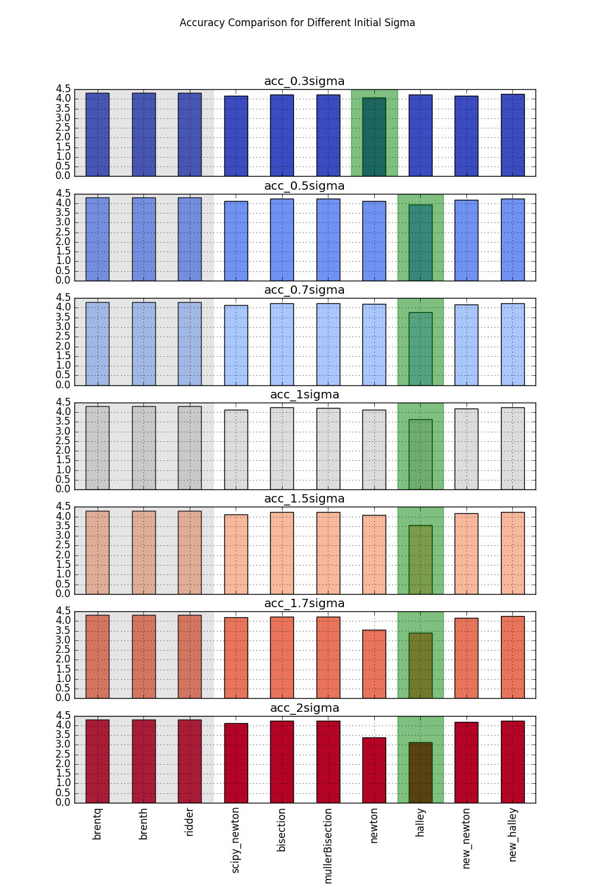
Figure 1. Accuracy Comparison for Different Initial Sigma

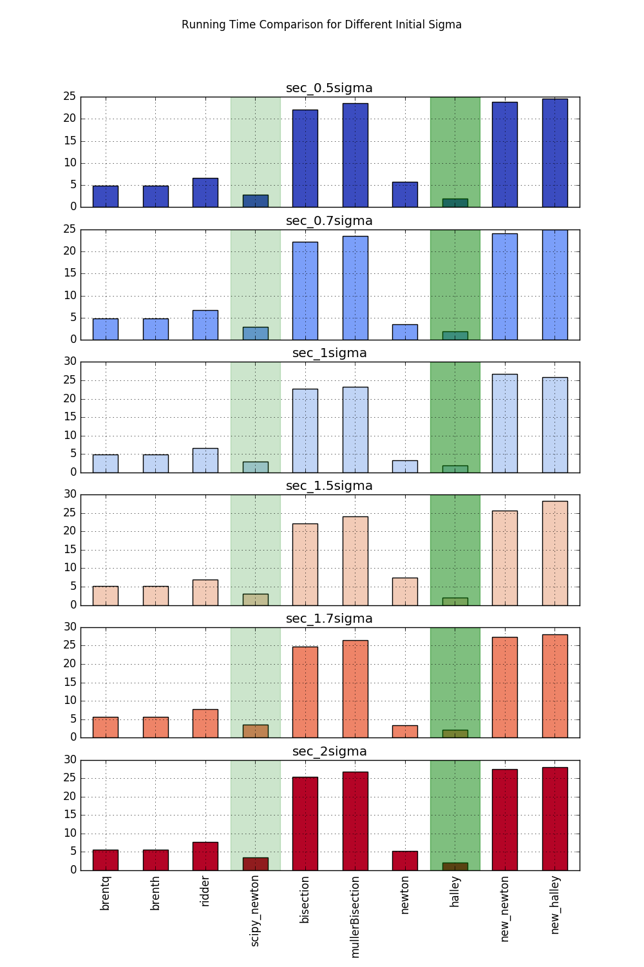
Figure 2. Running Time Comparison for Different Initial Sigma

